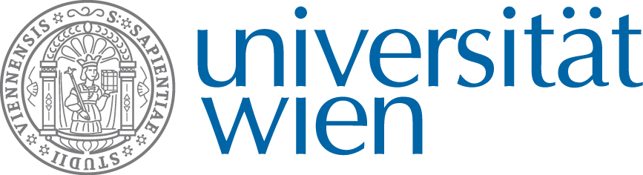
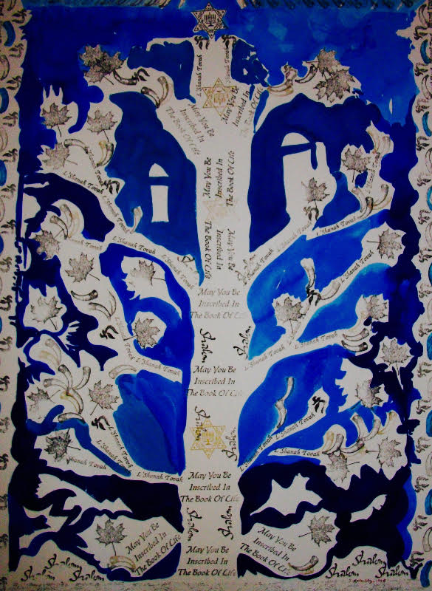

In the Shadows of Religious Experience:

Hostility, Violence, & Revenge

*All times are set to Central European Time (Vienna Austria)*

October 6

13:30-14:00: Michael STAUDIGL & Jason ALVIS (Vienna), “Introduction: On secularism and its discontents, or: Why a Conference about the Dark Sides of Religious Experience?”

Session 1: Phenomenologies of Religious Violence (Moderator: Michael Staudigl)

14:00-14:30: Tareq AYOUB. Heroism and Being-Towards-Death: On Martyrdom in Contemporary Shi’ism
14:30-15:00: Nuzhat KHURSHID, “Legitimizing Transgression Within Faith. Islamic Psychoanalysis and Muslim Women’s Agency.”

Session 2: Revenge of the Sacred (Moderator: Michael D. Barber)

15:00-15:30: Thomas SOJER, “The conjuncture of religious revenge and attention: Looking at the “Pope’s revenge” through the eyes of Simone Weil”

15:30-16:00: Eric BIEN, “The Double-sidedness of the Frown: Revenge as a Spiral of Satisfaction and Provocation”

16:00-16:30 ****BREAK****
16:30-17:30: Keynote lecture by J. AARON SIMMONS, “There are A-holes Everywhere on BS Mountain: Evangelical Conspiracism and Epistemic Violence” (Moderator: Jason W. Alvis)

Session 3: The Politicization of Transcendence (Moderator: Emil Salim)

17:30–18:00: Jan CERNY, “Étienne Balibar: Secularization as a Suppression or Transformation of Religious Experience?”

18:00-18:30: Thomasz NIEZGODA, “Violence as an Response. Eric Voegelin on the Ambivalence of the Experience of Transcendence”"

18:30-19:00 - ****BREAK****

Session 4: Reassessing Political Theology (Moderator: Jason Alvis)

19:00-19:30: Michele GIULI, “George Bataille’s interpretation of the Death of God as a way to understand the postmodern human condition”

19:30-20:00: Ahmad BOSTANI, “Phenomenology of the Imagination and Anti-Secular Ideologies: Henry Corbin’s Theologico-Political Legacy Reconsidered”

20:00-20:30: Paul SLAMA, “On the ‘psycho-theological’ structure of modernity and social violence”

October 7

Session 5: Enmity and the politicization of religious truth (Moderator: Michael Staudigl)

14:00-14:30: Osman Gazi BIRGÜL, “On the Politicization and Instrumentalization of Truth:
A Hermeneutical Phenomenological Analysis”
14:30-15:00: Macej WITKOWSKI, “Philosophy, Catholicism and Judaism in inter-war Germany: Walter Benjamin and Carl Schmitt on political violence”
15:00-15:30: Barbara LORENZ, “Migration of religious narratives of hostility & violence in (post)modern conspiracy myths”

15:30-16:00: Georg HARFENSTELLER, “Hostility and the effective direction of religious communitarisation”

16:00-16:30 ****BREAK****

16:30-17:30 Keynote lecture by NEAL DE ROO, "Locating Religious Violence in the Spiritual Constitution of Experience." (Moderator: Olga Louchakova-Schwartz)

Session 6: Denials and Possibilities of Transcendence (Moderator: J. Alvis)

17:30-18:00: Michael BARBER, “Nietzsche and Levinas against Innocence”

18:00-18:30: Matt ROSEN, “‘This is our testimony to the whole world’: A Quaker Phenomenology of Peace”

18:30-19:00: Eleni LORANDOU, “Embodying the universe: reviewing religious transcendence through Merleau-Ponty’s narratives of artistic engagement.”

19:00-20:00: Sophere Presidential Address, OLGA LOUCHAKOVA-SCHWARTZ, “Thinking About the Obvious: Religious Experience and the First-Person Perspective (Moderator: Michael D. Barber)

October 8

Session 7: Difficult relations (Moderator: Michael Staudigl)

14:00-14:30: Walter S. STEPANENKO, “A Relational Phenomenological Reading of Two Parables and the Atonement as Revenge Reduction: Implications for Contemporary Approaches to Religion”
14:30-15:00: Antje KAPUST: “Shifting of violence in civil societies: Religion and violence”

Session 8: Complicating Oppositions, Transcending Binaries (Moderator: Martin Koci)

15:00-15:30: Emil SALIM, “Violence in Empedoclean Metaphysics”

15:30-16:00: Maria GOLEBIEWSKA, "The Phenomenal Aspects of Negativity and Negating according to Søren Kierkegaard"

16:00-16:30 ****BREAK****

Session 9: The Affective States and Spaces of Violence (Moderator: Olga Louchakova-Schwartz)

16:30-17:00: Robert APPELBAUM, “Religious Violence and Space: Two Incidents from the French Wars of Religion”

17:00-17:30: Raphael COHEN-ALMAGOR, “Indivisibilité, sécurité, laïcité: The Burqa and the Niqab in France”

17:30-18:00: Felix Ó MURCHADHA: “Enthusiasm, Superstition and Religious Violence”

Session 10: Secular Violence, esp. in the Case of Canada (Moderator – Jason Alvis)

18:00-18:30: Jennifer GUYVER, “Protecting the legitimacy of state violence through laïcité: the case of Quebec”
18:30-19:00: Seraphine APPEL, “Ideological Structures of ‘Reconciliation’”
19:00-19:30: Damian BARNAT, “Religious and Secular Responses to Violence. Charles Taylor aand Robert Drozek on the Moral Transformation”

19:30 Closing Remarks – End of the Conference

* * *
This webinar is conducted within the framework of the Society for the Phenomenology of Religious Experience, is based at the University of Vienna in the Institute for Philosophy, in cooperation with the "Centre for Religion and Transformation", and with the financial support of the FWF research grant "Revenge of the Sacred: Phenomenology and the ends of Christianity in Europe" (FWF P 31919)

